**3. CONTEXT AND SITUATION ANALYSIS**

The Paynesville city context and situation analysis reflect the city demographic, socio-economic, political and SWOT analysis. These type of analysis is used to gauge external and internal factors that could impact the serviceability and growth of an organization. Generally, it is more effective with larger institutions/organizations such as the PCC that are more likely to experience the effects of macro events

**3.1 DEMOGRAPHIC CONTEXT/ANALYSIS**

Paynesville (sometimes called Paynesward) is located southeast of Monrovia, Liberia. The City has a total landscape of 90,000 Square feet. According to the Liberia Institute for Statistics and Geo-Information Services (LISGIS) 2022 Liberia Population and Housing Census final result, Paynesville has a population of over 617,492 residents, with 298,858 males and 318,634 females, while Monrovia, the Capital, has 161,891 inhabitants. It makes Paynesville the most populated City and is fast becoming the most commercial City in Liberia.

The population of Paynesville City is predominantly young, with 45% under 25, and boasts a high school graduation rate of 70%. Most residents are employed in the service sector, followed by agriculture and manufacturing. These demographic characteristics not only indicate potential economic growth and development in the City but also inspire hope for a brighter future, fostering a sense of optimism among the audience.

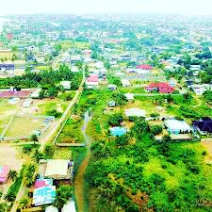

**Paynesville, Robert-field Highway**

**NACCROPS/LRA Building and ELWA Junction Round-About**

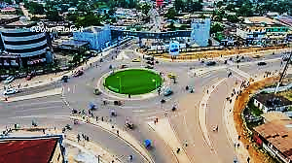

In comparison, Liberia's capital, Monrovia, is approximately 11.8 km / 7.3 mi away. It is geographically more significant than the City of Monrovia. It is expanding eastward along the Roberts-field Highway and northeastward beyond Red Light Market. Some very noticeable features in this city are; the Paynesville Omega 14 International market, the Liberia Broadcasting System (LBS), the SKD Sport Complex, the largest sport complex in Liberia and the Red Light market, the largest market areas in Liberia and the country biggest vocational training institute / MVTC. Others are the ELWA Hospital one of the biggest hospital in Liberia, NACCROPS/LRA Building, Liberia most popular ELWA junction Round-about, Coco Cola factory, Jemale Diagnosis Center, RLJ Hotel, etc.

**SKD Sports Complex, Paynesville**

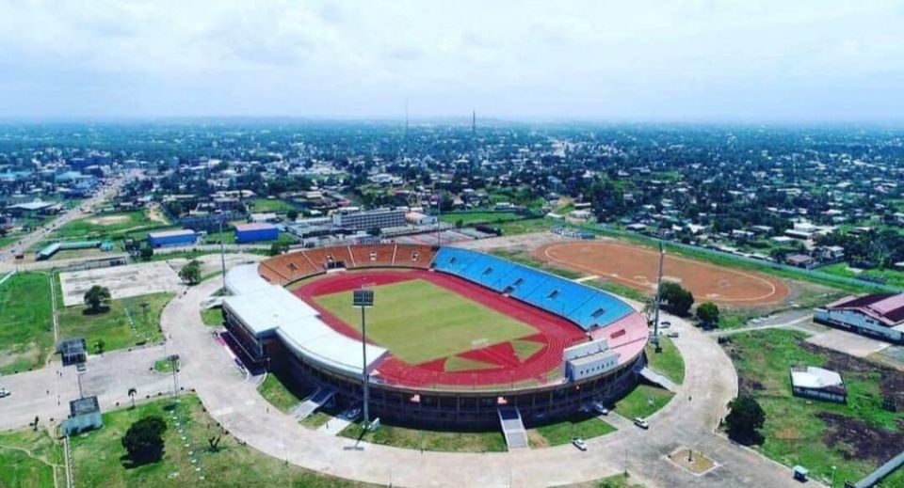

These institutions, along with the City's strategic location and growing population, contribute to the City's economic growth and potential for further development, particularly in the media and communication sectors. The city was nominated in 2014 and accepted in 2016 as one of the 100 Resilient Sister Cities (100RC) worldwide. Amidst the daily municipal duties, functions, and challenges, Paynesville is a striving City. It is facing numerous complex problems, including congestion, garbage disposal, and street vending, amongst others. The coming in of a new City Mayor and the developed Strategic Plan (long-term plan) provide opportunities in addressing the city complex of issues.

**Paynesville, Red-Light Market**

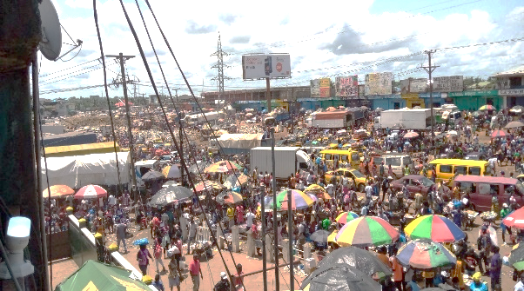

**Table ……: LISGIS 2022 Census Statistics Matrix**

Montserrado County - Population Distribution by County, Administrative District, and Sex

|  |  |  |  |  |
| --- | --- | --- | --- | --- |
| # | Administrative Districts | Total | Male | Female |
| 1 | Montserrado County | 1,920,965 | 942,559 | 978,406 |
| 2 | Careysburg | 55,284 | 27,611 | 27,673 |
| 3 | West Point Township | 30,847 | 15,915 | 14,932 |
| 4 | St. Paul River | 172,384 | 85,174 | 87,210 |
| 5 | Todee | 49,361 | 25,754 | 23,607 |
| 6 | Borough of New Kru Town | 71,739 | 35,724 | 36,015 |
| 7 | Gardnersville Township | 127,566 | 62,270 | 65,296 |
| 8 | Barnersville Township | 65,493 | 31,254 | 34,239 |
| 9 | Lousana Township | 26,057 | 13,033 | 13,024 |
| 10 | Paynesville Township | 617,492 | 298,858 | 318,634 |
| 11 | Congo Town Township | 91,632 | 44,161 | 47,471 |
| 12 | New Georgia Township | 99,845 | 49,017 | 50,828 |
| 13 | Caldwell Township | 112,166 | 54,055 | 58,111 |
| 14 | Greater Monrovia | 161,891 | 81,659 | 80,232 |
| 15 | Garglohn Township | 126,281 | 63,432 | 62,849 |
| 16 | Johnsonville Township | 112,927 | 54,642 | 58,285 |

**3.2 SOCIO-ECONOMIC CONTEXT/ANALYSIS**

Paynesville City is the largest City in Liberia. Its rapid growth is due in part to the uncontrolled growth of the City of Monrovia. Monrovia, the nation's capital, has experienced rapid population growth for it size, which has led to the City's massive deterioration of infrastructure and reduction in its capacity for service delivery.

The cost of living and doing business in Monrovia has increased by 100%, which could be more unsustainable. As a result, many businesses and residents of Monrovia are relocating to the neighboring City of Paynesville. Today, the City of Paynesville, with over 600,000 residents and growing, is experiencing the signature challenges of major metro-cities due to the overwhelming demand for programs and services by its residents: Less economic opportunities and low employment, Poor city infrastructure and Minimum access to very important services.

The socio-economic challenges in Paynesville are further exacerbated by governance issues. Corruption, mismanagement, and inequality have significantly increased poverty in the city. These issues like in other parts of the country, have not only hindered the effective delivery of public services but also the implementation of poverty alleviation programs, thereby worsening the socio-economic situation.

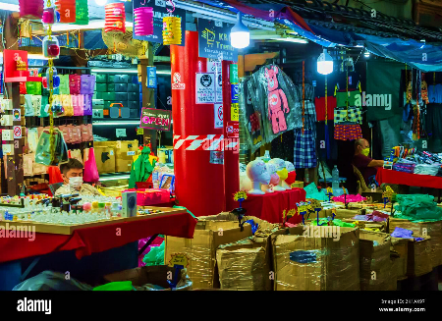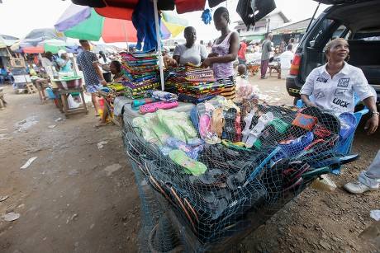

**Small Businesses in Paynesville**

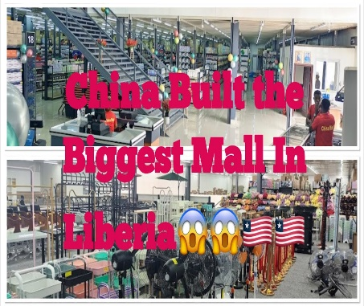Thanks to the successful partnerships established by previous administrations of the City corporation, such as those with the Liberian Marketing Association, businesses (stores, hotels, etc.), petty trader organizations, transport unions, and other organizations, significant progress has been made in improving the trade environment and increasing benefits through economic returns. These partnerships have led to the implementation of various initiatives, such as business training programs, infrastructure development projects, and market access support, all of which have directly contributed to the growth of local businesses and reduced unemployment rates.

Developing and implementing city plans to repair infrastructure and improve service delivery would address these challenges and pave the way for a thriving local economy in Paynesville.

The City and the private sector's engagement in industrialization, tourism, education, and other business activities, which can thrive in a densely populated, well-connected population, will contribute to Paynesville City's urban growth.

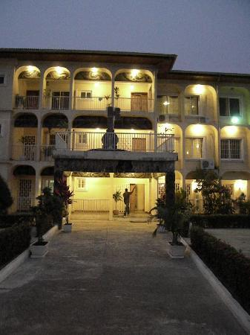

**Golden Key Hotel, King Gray**

Some sectors offer promising economic growth and development opportunities in Paynesville. The city's Industrialization plan/strategy can create jobs, stimulate economic growth, and increase government revenue through taxes. A well-in-placed tourism programs can generate much-needed foreign exchange earnings and boost local businesses with employment opportunities in hospitality, transportation, and other services in different sectors.

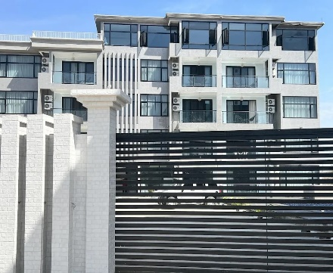

**Lifestyle Luxury Hotel,**

**Thinkers-village**

Education can improve human capital and productivity and encourage critical thinking and problem-solving skills. Other businesses and activities can increase access to goods and services.

These sectors offer promising economic growth and development opportunities in Paynesville City, benefiting all stakeholders.

**3.3 POLITICAL CONTEXT/ANALYSIS**

The municipality is managed by a local government authority called the Paynesville City Corporation (PCC), and the administrative and political head is the City Mayor of Paynesville.

Paynesville, the largest city in Liberia, has a robust local governing structure, a testament to the democratic governance that Liberians enjoy. The city is divided into neighborhoods or communities, zones, and districts, each with its leadership team. These leaders, whether community volunteers or elected district representatives, play a crucial role in managing the affairs of their respective divisions, that should ensure every voice is heard and represented. This strong local leadership should instill a sense of confidence about the City's ability to address its challenges and foster development.

Paynesville City has several neighborhoods, called "communities", which are notable for their unique names. Some communities are named after housing estates, older settlements, landmarks, significant boulevards/roads, or local leaders, while others predate the street names altogether. Some noticeable communities in Paynesville are A.B. Tolbert Community, Duport Road, ELWA, Kendeja

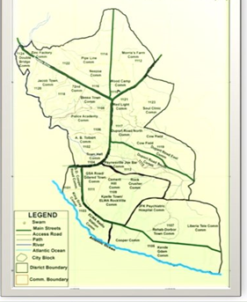

Map of Paynesville and Communities

Kenny Town; King Gray Town, Parker-Paint, Police Academy, Rehab Road, Peace Island, SD Cooper Road, SKD Boulevard, GSA Road, Soul Clinic, Wien Town, etc.

Paynesville has five electoral districts, the highest of any city in the country. They include District #2, District #3, District #4, District #5, and District #6). These districts facing significant responsibilities and challenges requiring adequate resources.

Political activities, including rallies and demonstrations, are regular fixtures within the political space in the city due to the City huge population and availability of space for national political parties' activities.

Influential leaders in both civic and other organizations active in advocacies, human rights, community development, traditional and opinion leaders play significant roles in local governance and community affairs.

**4. STRATEGIC DIRECTION (2024-2029)**

**STRATEGIC DIRECTION (2024-2029)**

The PCC strategic plan clearly articulated its vision, mission, and core values.

This section presents the Paynesville City Corporation's vision, mission, and core values, which not only direct and drive our strategy, interactions, and relationships with stakeholders but also significantly impact their lives. This strategic plan is designed to draw attention to, focus on, and provide a solutions-driven roadmap that improves and enhances the quality of life of our citizens, demonstrating our unwavering commitment to their interests and well-being. We understand that our citizens are at the heart of our city, and their well-being is our top priority.

**4.1 VISION STATEMENTS**

Our vision is not a mere statement but a profound belief that every citizen holds significance and that every visitor is esteemed. This belief, deeply ingrained in our vision, it propels us to provide exceptional city services and governance.

*‘’We Pride Ourselves To Provide Exceptional City Services and Governance, Where Citizen Matters and Visitors are valued’’.*

**4.2 MISSION STATEMENTS**

Our plan provides an unwavering commitment to our mission, instills confidence and trust in our capabilities, ensuring that everyone feels acknowledged and respected. We are dedicated to this mission, and we will not waver in our efforts to achieve it.

*‘’Providing Excellent City Services, Trusted Stewardship and Inclusive Community Partnership, for all people Who Live, Work and Visit the Great City of Paynesville’’.*

**4.3 CORE VALUES**

PCC is not just committed but unwaveringly dedicated at all times to the following core values:

|  |  |
| --- | --- |
| Integrity Leadership | Believes in being accountable and transparent to our stakeholders and the Liberian people in everything we do |
| Excellent City Services | Building a culture of daily improve city service, quality performance and giving our best in everything we do. |
| Inclusiveness | Respects the equal participation for all, while at the same time benefiting from the diversity and differences of people within our operations |
| Partnership | Working with different partners (domestic and international) to facilitate development of different sectors that transform the lives of citizens and others in our city limit |
| Innovation | Driven by fast changing environment and innovation to stay relevant, effective and efficient to our stakeholders |